Write a Python Script for storing Player Name, Player Team, Player Role of some Cricket Players

Inserting one document at a time:

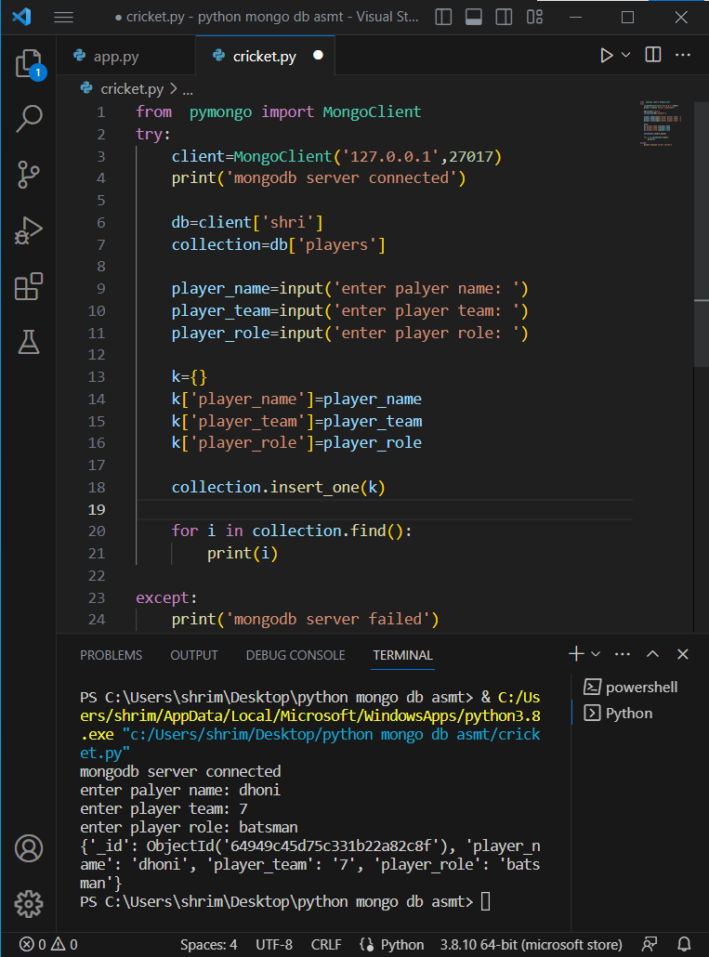

Inserting many documents at a time:

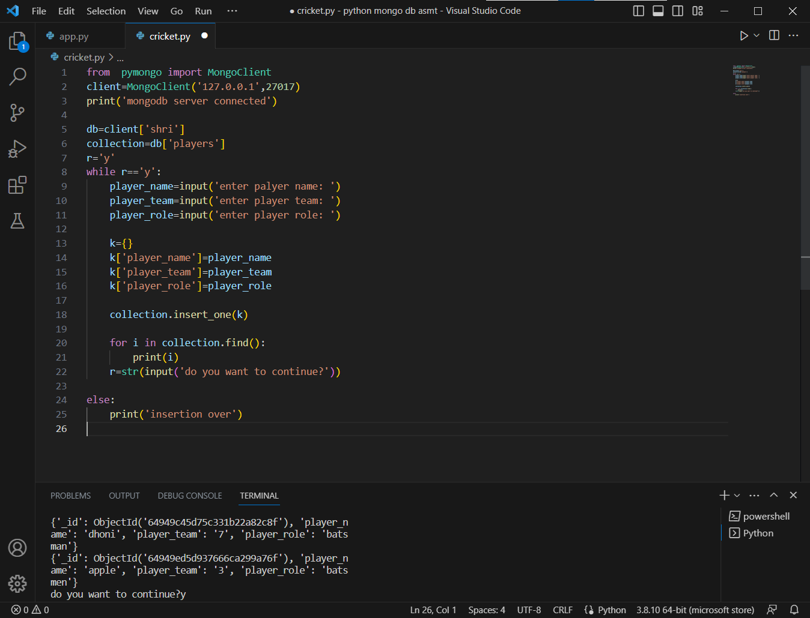

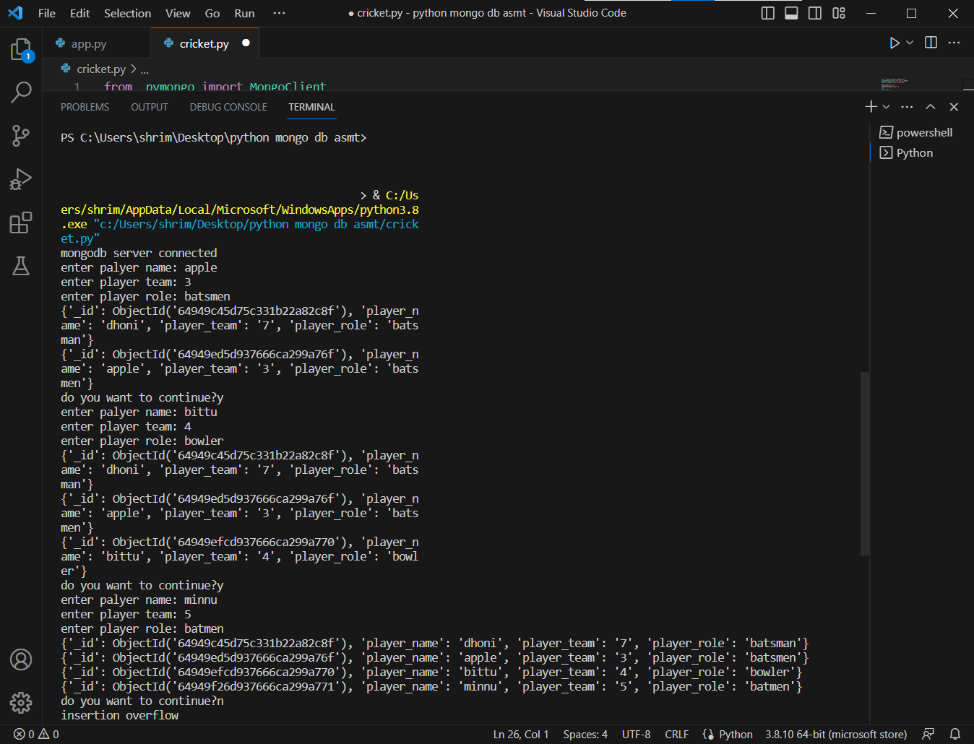

Updating a document:

